TOURNAMENT DIRECTOR CRIB SHEET
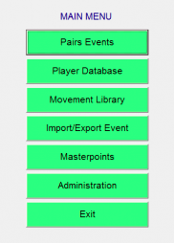
TO BEGIN: LAUNCH EBUSCORE PAIRS from the desktop. CLICK PAIRS EVENTS
NB: The colours have changed throughout as we are now using ArcScorer rather than Bridgemates. – this makes no difference to the setting up of EBU score.

NEXT SCREEN: USE THE TABS AT THE BOTTOM OF THE SCREEN.
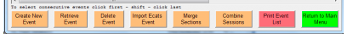
CLICK
CREATE NEW EVENT

NEXT SCREEN
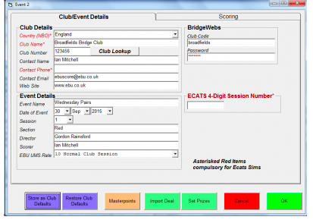
ENTER EVENT NAME in the EVENT box. ALWAYS use the format (EG) Monday Afternoon
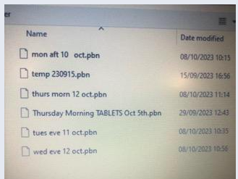
ENTER your name in the DIRECTOR box.
CLICK IMPORT DEAL to see an empty list.
CLICK IMPORT DEAL again to see a dialog box,
which now looks slightly different: see right.

DOUBLE CLICK the session you have chosen.
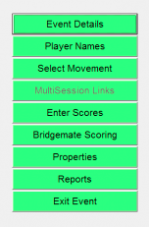
DOUBLE CLICK the DATA folder and select the .pbn file. CLICK OPEN. CLICK OK then OK again on the next screen to take you back to the EVENTS MENU.

EVENTS MENU SCREEN: CLICK SELECT MOVEMENT
NB: ONLY do this once you are sure how many tables you will have in play.

NEXT SCREEN
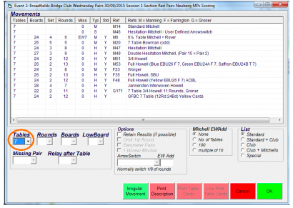
ENTER the number of tables.
SELECT appropriate movement from the list.
ENTER a missing pair if appropriate.
CLICK OK to return to the EVENTS MENU.
IMPORTANT!!!! CLICK ARCSCORER SCORING.
DO NOT change the BCS settings.

CLICK CREATE DATABASE.
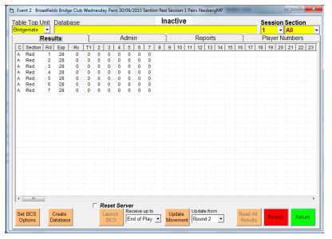
NEXT SCREEN

CLICK LAUNCH BCS.
At the prompt CLICK YES.

THE SESSION IS NOW PREPARED
PTO: Instructions for after the session.
AFTER THE SESSION

CLICK ENTER SCORES from the main menu. ALTER any scores and ADD NAMES if necessary. (Follow the prompts).

RETURN to EVENTS MENU. CLICK REPORTS. CLICK PRINTER PREVIEW and PRINT.
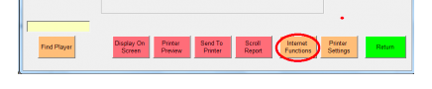
CLICK INTERNET FUNCTIONS.

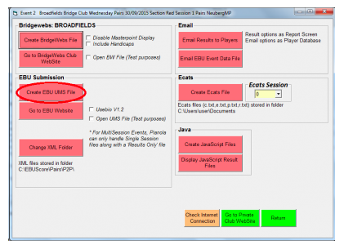
IMPORTANT CHANGES: YOU ONLY NOW NEED TO CLICK ON ONE BOX:
CREATE EBU/UMS FILE

CLICK EXIT EVENT. CLICK EXIT on the main menu.

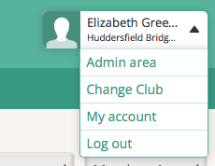
ADD THE RESULTS TO PIANOLA

LOG IN, CLICK on your name, and then on ADMIN

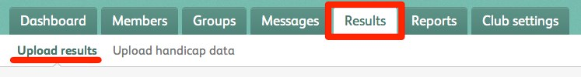
NEXT SCREEN

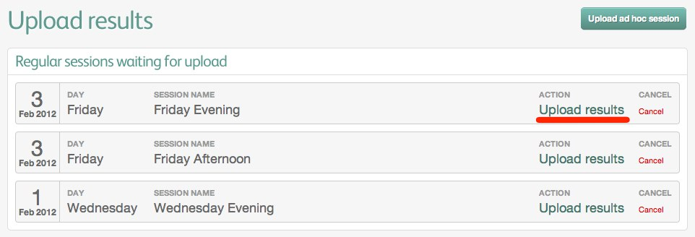
CLICK RESULTS in the top bar.

NEXT SCREEN
CLICK UPLOAD RESULTS for the session you have just scored.

NEXT SCREEN
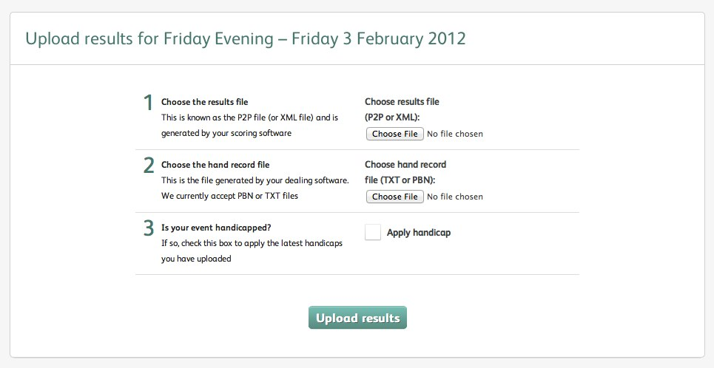
CLICK 1: CHOOSE RESULTS FILE and BROWSE for the XML or P2P file.
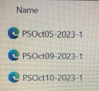
IMPORTANT CHANGE: THIS WILL NOW ALWAYS BE ON THE DESK TOP, IN A FOLDER MARKER UMS/XML FILES.
The XML FILE NOW LOOKS LIKE THIS:

The list of files should come up automatically, and the most recent session will be at the top.
CLICK on the date for this session.
CLICK 2: CHOOSE HAND RECORD DATA. FIND THE P2P FILE (RED AND BLACK) AND AGAIN CHOOSE TODAY’S SESSION. CLICK UPLOAD RESULTS. (Don’t worry about Box 3).
Once the PROCESSING MESSAGE disappears – within seconds – you can be confident it’s all worked.
You may see a QUEUED message – this is normal and any further messages are for me to sort out. Please close programs and close down the computer.

